**1.Develop a program to display grayscale image using read and write operation.**

**------------------------------------------------------------------------------------**

import cv2

import numpy as np

image = cv2.imread('catflower.jpg')

image = cv2.resize(image, (0, 0), None, .25, .25)

grey = cv2.cvtColor(image, cv2.COLOR_RGB2GRAY)

grey_3_channel = cv2.cvtColor(grey, cv2.COLOR_GRAY2BGR)

numpy_horizontal = np.hstack((image, grey_3_channel))

numpy_horizontal_concat = np.concatenate((image, grey_3_channel), axis=1)

cv2.imshow('catflower', numpy_horizontal_concat)

cv2.waitKey()

**OUTPUT**

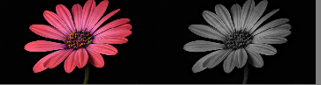

**2.Develop a program to perform linear transformation on image.**

**------------------------------------------------------------------------------------------------**

import cv2

import numpy as np

FILE_NAME = 'catflower.jpg'

try:

img = cv2.imread(FILE_NAME)

(height, width) = img.shape[:2]

res = cv2.resize(img, (int(width / 2), int(height / 2)), interpolation = cv2.INTER_CUBIC)

cv2.imwrite('result.jpg', res)

cv2.imshow('image',img)

cv2.imshow('result',res)

cv2.waitKey(0)

except IOError:

print ('Error while reading files !!!')

cv2.waitKey(0)

cv2.destroyAllWindows (0)

**OUTPUT**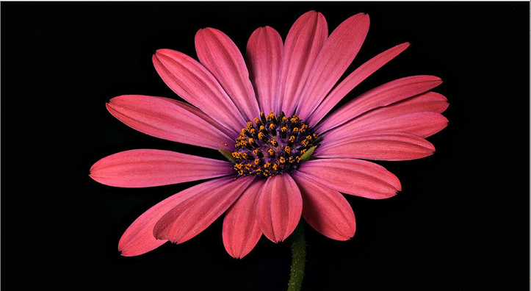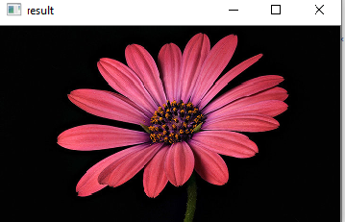

**3.Develop a program to find sum and mean of a set of images.**

**Create n number of images and read the directory and perform operation.**

Import cv2

import os

path = "E:\ip2"

imgs=[]

dirs=os.listdir(path)

for file in dirs:

fpat=path+"\\"+file

imgs.append(cv2.imread(fpat))

i=0

for im in imgs:

cv2.imshow(dirs[i],imgs[i])

i=i+1

print(i)

cv2.imshow('sum',len(im))

cv2.imshow('mean',len(im)/im)

cv2.waitKey(0)

**OUTPUT:**

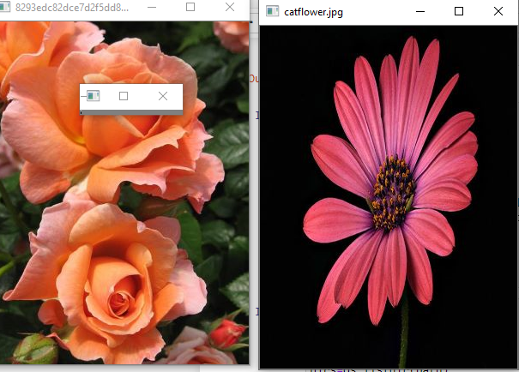

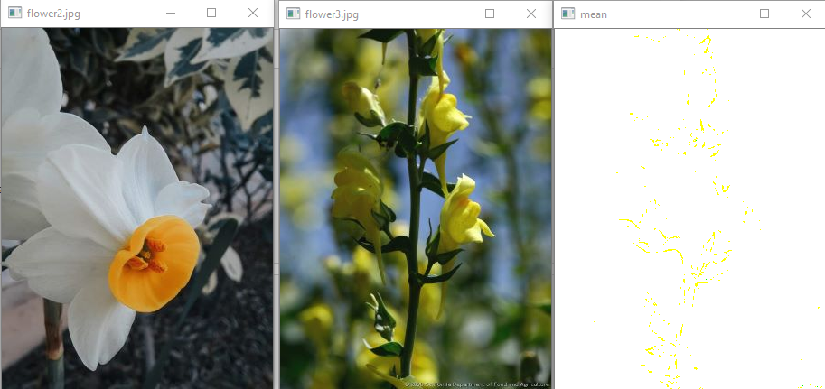

**4. Write a program to convert color image into gray scale and binary image.**

import cv2

img = cv2.imread("catflower.jpg")

gray=cv2.cvtColor(img,cv2.COLOR_BGR2GRAY)

cv2.imshow("Binary Image",gray)

cv2.waitKey(0)

cv2.destroyAllWindows()

ret, bw_img = cv2.threshold(img,127,255,cv2.THRESH_BINARY)

cv2.imshow("Binary Image",bw_img)

cv2.waitKey(0)

cv2.destroyAllWindows()

**OUTPUT:**

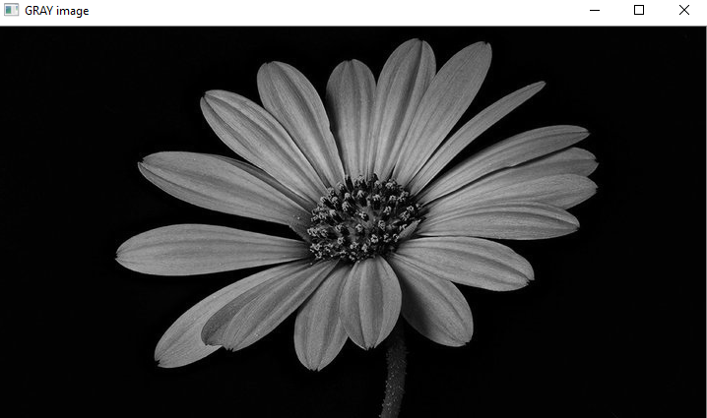

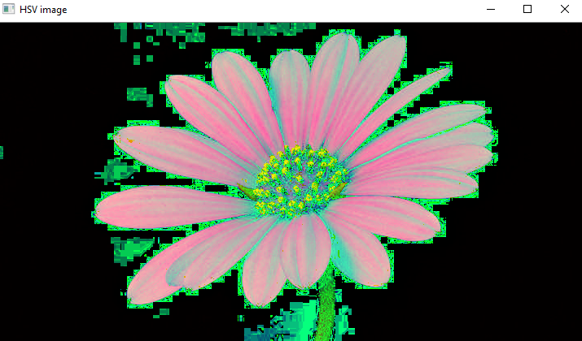

**5. Write a program to convert color image into different color space.**

Import cv2

Img = cv2.imread ("Cat.jpg")

gray=cv2.cvtColor(img,cv2.COLOR_BGR2GRAY)

hsv=cv2.cvtColor(img,cv2.COLOR_BGR2HSV)

lab=cv2.cvtColor(img,cv2.COLOR_BGR2LAB)

hls=cv2.cvtColor(img,cv2.COLOR_BGR2HLS)

yuv=cv2.cvtColor(img,cv2.COLOR_BGR2YUV)

cv2.imshow("GRAY image",gray)

cv2.waitKey(0)

cv2.imshow("HSV image",hsv)

cv2.waitKey(0)

cv2.imshow("LAB image",lab)

cv2.waitKey(0)

cv2.imshow("HLS image",hls)

cv2.waitKey(0)

cv2.imshow("YUV image", yuv)

cv2.waitKey(0)

cv2.destroyAllWindows()

ret, bw_img = cv2.threshold(img,127,255,cv2.THRESH_BINARY)

cv2.destroyAllWindows()

**OUTPUT:**

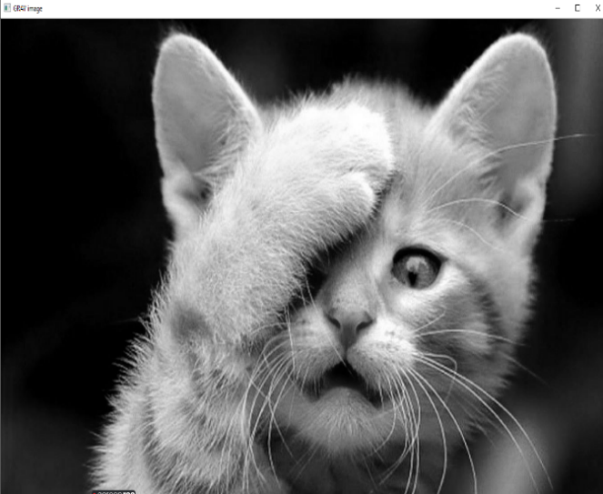 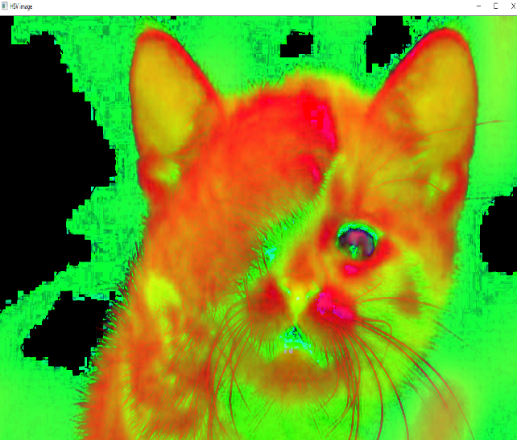

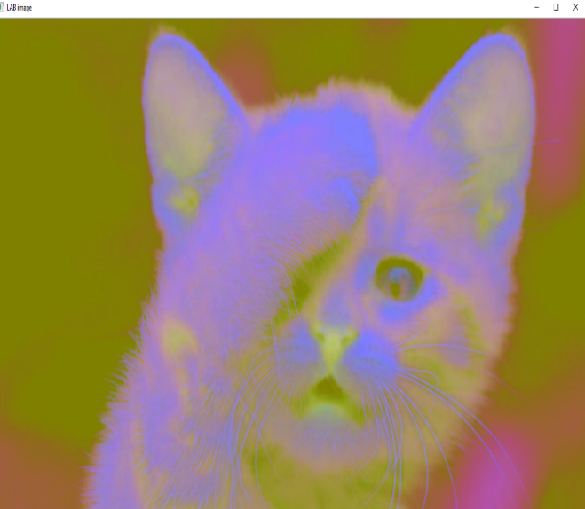 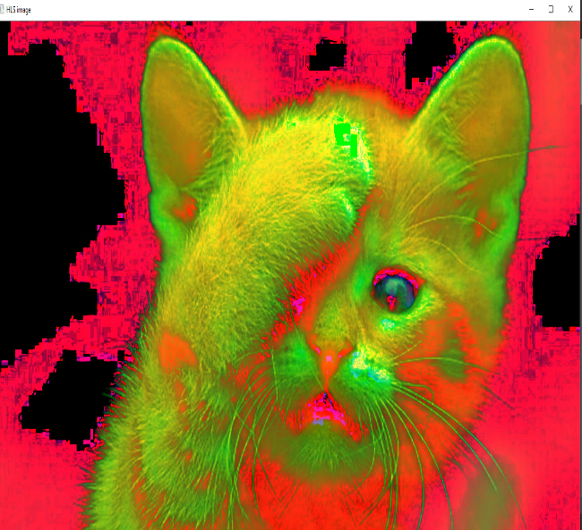

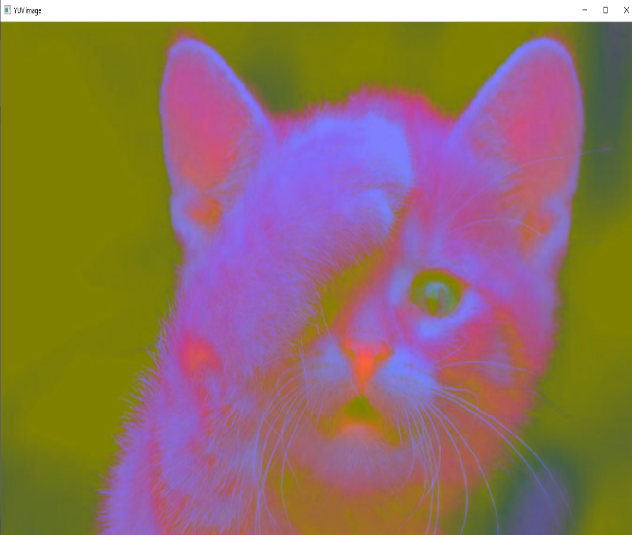

**6.Develop a program to create an image from 2D array.**

**------------------------------------------------------------------------------------------------**

from PIL import Image

import numpy as np

w, h = 512, 512

data = np.zeros((h, w, 3), dtype=np.uint8)

data[0:256, 0:256] = [255, 0, 0] # red patch in upper left

img = Image.fromarray(data, 'RGB')

img.save('my.png')

img.show()

**OUTPUT:**

